My name is Kerstin Wallin, during my education to a special teacher I took level 1 and 2 in SDM.
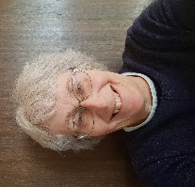
I worked with children with autism and SDM was a daily activity for them. Later, I worked with children with Downs syndrome. I finished my ICL education in 2003 and I have been part of the Swedish board since 200. For 14 years I was the chair, but becoming a representative for ISCO, I am now just a commissioner. Since 2015 I am part of the panel that worked with the new structure for SDM. I am a retired teacher but keen to work with Sherborne 😊

